**Lab 5: Embedded C basics**

**__________________________________________________________________________**

**Name: Roll Number:**

**___________________________________________________________________________**

**PART1**

This labsheet is based on uVision 4.74.0.22 and Texas Instruments Tiva LaunchPad, which contains a TM4C123GH6PM microcontroller.

1. Create a new folder named **project1** in **My Documents**. (The folder/file name and the location of the folder are arbitrary. They were selected only for the purpose of this demonstration.)
2. Launch Keil uVision4.

## Create a Project with the Guidance of Project Wizard

1. From the menu, select Project > New uVision Project…

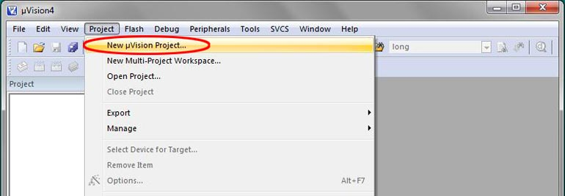

1. In the New uVision Project window, browse to the folder **project1** you just created at **My Documents**.
2. If you did not create a folder for the project before launching uVision, you may create a folder using the **New folder** menu item in the **Create New Project** window.
3. Enter a name for the project file. We will call it **project1** and click **Save**.
4. A **Select Device for Target ‘Target 1’…** window will pop up. The device used on the Tiva LaunchPad is Texas Instruments TM4C124GH6PM. To select this device, type the device name as **TM4C123GH6PM**, click on the device name then click **OK**.

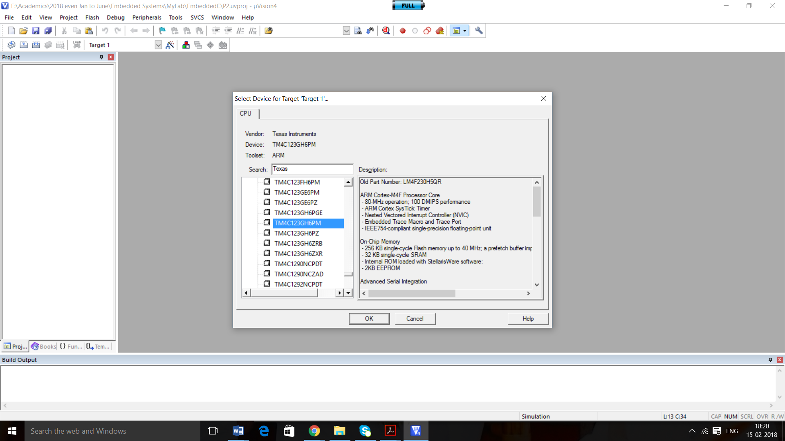

1. A dialog box pops up and asks whether you like to copy ‘startup_TM4C123.s’ to the Project. It is necessary to initialize a few things in the processor before starting a C program in this assembly file. Click **No** to deny it and later add the correct startup.s given for you along with the labsheet.
2. In the Project window, a target is created with the default name **Target1**. Click on the **+** sign to the left of Target1 to expand the folder.
3. A default folder for source code files is created with the name **Source Group 1**. Place the Startup.s file given for you in this folder.



# Add a Source File to the Project

1. Click the **New** button to add a new text file to the display with the default name **Text1**.
2. From the menu, select **File > Save As…** to open the Save As dialog box. Browse to the project folder if it is not already there. Type in the file name **main.c** and click **Save**.
3. You will notice the file name in the tab changed to main.c
4. The new file needs be added to the project. Right click on the folder **Source Group 1** in the Project window and select **Add Existing Files to Group ‘Source Group 1’…**
5. In the dialog box, browse to the project folder if it is not already there. Click select **main.c** then click **Add**.
6. The file should appear in the project window under Source Group 1 folder. Click Close to close the dialog box.
7. Copy and paste the following code into the main.c editor window.

**int main(void){   
long x,y,z;    // Three local variables   
   x=1; y=2;   // set the values of x and y   
   z = x+4*y;  // arithmetic operation     
   x++;        // same as x=x+1;         
   y--;        // same as y=y-1;        
   x = y<<2;   // left shift same as x=4*y;         
   z = y>>2;   // right shift same as x=y/4;        
   y += 2;     // same as y=y+2;         
}**

**Q1 Find the instructions for each of the above C program. Identify the registers for the variables x, y and z and trace the changes during the program execution**

Note: You can also use the Watch Window to trace the variables. **Watch Window:** Go through View-> Watch Windows-> Watch-1; this window allows you to view variables or memory while the program is running; and also you can modify these values without disturbing (or stopping) the program.

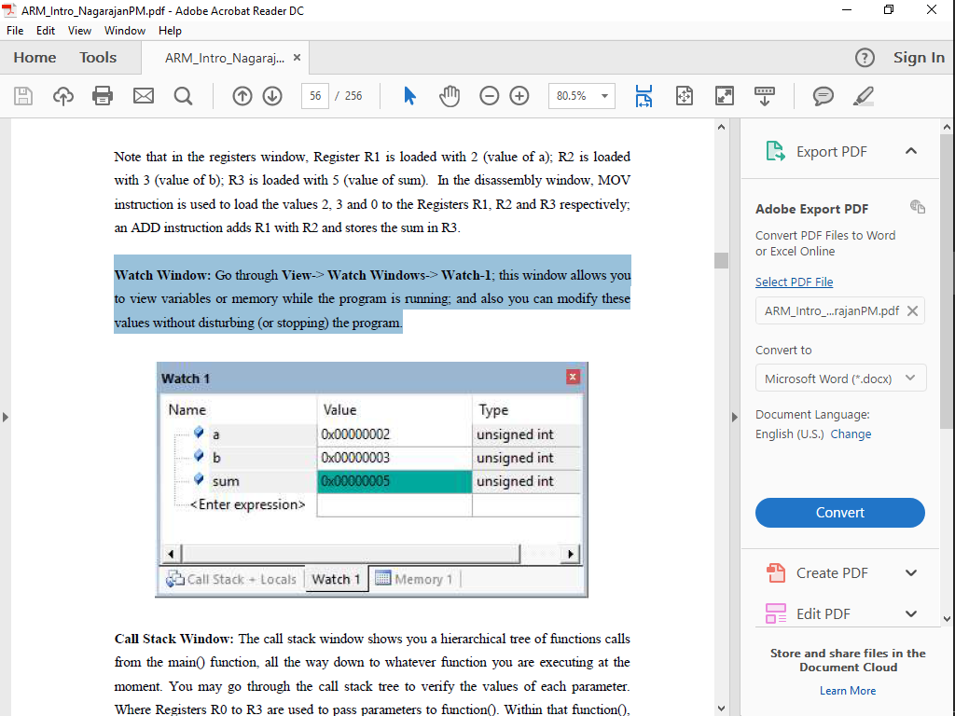

**Q2 Mention the Instruction address, Machine code, instruction and interpretation of the instruction with respect to the below C program as comment. Identify the registers used for the given variables. What is the content of R14 register during the function call and justify your answer?**

long sum(long x, long y){

long z;  
 z = x+y;  
 return(z);  
}

void main(void){

long a,b;  
 a = sum(2000,2000);  
 b = 0;

while(b < 5){  
 b = sum(b,1);

}  
}

**PART 2**

Write the embedded C code for the following and simulate using Keil IDE.

1. Let the marks of top 6 students for the course 15ECE382 is stored in an array. Sort them in ascending order.
2. Implement a Logical Calculator. Perform logic operations such as AND, OR, NOT, XOR, NAND; SHIFT RIGHT.
3. Calculate grade according to the following conditions; If mark is above 85 then Grade=A; If >=70 & <85 then Grade=B; If >=55) & <70 then Grade=C; If >=40 & <54, then Grade=D; If below 40 then Grade=Fail.